MINI PROJECT
(2019-2020)

Instant Update Database Project
(Web development)

Department of Computer Engineering & Applications

Institute of Engineering & Technology



GLA University, Mathura

Institute of Engineering & Technology

Supervised By: - Team Member: -
Mrs. Priya Agrawal Siddharth
(Trainer) 171500340




Department of computer Engineering and Applications
GLA University, Mathura
17 km. Stone NH#2, Mathura-Delhi Road, P.O. – Chaumuha, Mathura – 281406

Declaration

I hereby declare that the work which is being presented in the Mini Project Titled: “Instead update database”, in partial fulfillment of the requirements for Mini-Project LAB, is an authentic record of our own work carried under the supervision of Dr. Priya Shrivastava, Technical Trainer, GLA University, Mathura.

Signature of Candidate:
Name of Candidate: Siddharth
Roll. No.: 1715000340

Course: B-tech

Year: 3rd

Semester: Vth

Department of computer Engineering and Applications
GLA University, Mathura
17 km. Stone NH#2, Mathura-Delhi Road, P.O. – Chaumuha, Mathura – 281406

CERTIFICATE

This is to certify that the project entitled “Instead update database” carried out in Mini Project – I Lab is a Bonafede work done by Sidharth (171500340) and is submitted in partial fulfillment of the requirements for the award of the degree Bachelor of Technology (Computer Science & Engineering).

Signature of Supervisor:
Name of Supervisor: Priya Agrawal
Date: 28/08/2020

ACKNOWLEDGMANT

It gives us a great sense of pleasure to present the report of the B. Tech Mini Project undertaken during B. Tech. Third Year. This project in itself is an acknowledgement to the inspiration, drive and technical assistance contributed to it by many individuals. This project would never have seen the light of the day without the help and guidance that we have received.

Our heartiest thanks to Dr. (Prof). Anand Singh Jalal, Head of Dept., Department of CEA for providing us with an encouraging platform to develop this project, which thus helped us in shaping our abilities towards a constructive goal.

We owe special debt of gratitude to Dr. Priya Agrawal, Technical Trainer, Department of CEA, for his constant support and guidance throughout the course of our work. His sincerity, thoroughness and perseverance have been a constant source of inspiration for us. He has showered us with all his extensively experienced ideas and insightful comments at virtually all stages of the project & has also taught us about the latest industry-oriented technologies.

We also do not like to miss the opportunity to acknowledge the contribution of all faculty members of the department for their kind guidance and cooperation during the development of our project. Last but not the least, we acknowledge our friends for their contribution int the completion of the project.

ABSTRACT

This project is a web-based Instead update database system. The project objective is to deliver the online video listing application into web platform.
This project is an attempt to provide the advantages of real time updating of data base to customers likening and showing them their favourites list being updated in real time. It helps them to separate their favourites in the personal list and can see them anywhere through internet by using an internet device. Thus, the customer will get the service of online Instead update database.
This site can filter the list according to their customer choice and list them according to that and display that on homepage of user login just like YouTube, twitch, etc.
This site consists of administration portal and the user portal.
Administrator can add, delete, check quantity of the items presents in it. And user can see items that are available on site and sort them according to its own needs using filtering available on them.

Student Information
Name : Siddharth | University Roll No.: 171500340
Mobile : 7579575053 | Email : siddharth.gla1_cs17@gla.ac.in
Information about Industry/Organization:

Origination | GLA University
Contact Person  Phone : | Mrs. Priya Agrawal  7452055666

Project Information:

Title of Project | Video listing site
Role & Responsibility
Technical Details | Hardware Requirement  Processor core i3 and above  Hard disk capacity 30GB  RAM 2GB  Resolution 800 X 600  Software Requirement  Operating System windows 7 and above  MacOS 10.8 and above  Browsers Chrome* 36+  Edge* 20+  Mozilla Firefox 31+  Safari 6+(MacOS only)

CONTENT

- About Project………………………………………………………………………………………….8
  - Introduction
  - Motivation
  - Objective
  - Scope of Project
- Technologies Used…………………………………………………………………………………….9
  - HTML
  - Java
  - CSS
  - PHP
  - MySQL
  - AJAX
  - jQuery
- Software Used…………………………………………………………………………………………12
  - Komodo Edit
  - XAMPP
- Implementation……………………………………………………………………………………….13
  - Modules
    - AJAX
    - CSS
    - functions
    - images
    - images-movies
    - php-includes
    - scripts
  - Source Code
  - Screenshots
- References…………………………………………………………………………………………….81

ABOUT

- Introduction:- An online video platform (OVP), provided by a video hosting service, enables users to upload, convert, store and play back video content on the Internet, often via a structured, large-scale system that may generate revenue. The type of video content uploaded might be anything from shorts to full-length TV shows and movies. The video host stores the video on its server and offers users the ability to enable different types of embed codes or links that allow others to view the video content. The website, mainly used as the video hosting website, is usually called the video sharing website. And my project is an attempt of making it with lesser features and replacing the videos with static images. And have features user wish list , adding and removing from list drag and drop feature for removal.

- Motivation:- To learn how to structure a website using HTML5. apply styling with cascading stylesheets (CSS). convert a static site to a dynamic one using PHP. remove inefficient duplicate code. use PHP functions to isolate variables. use MySQL and prepared statements for secure database queries. manipulate page content immediately with jQuery. update the database silently with AJAX

- Objective:- to make a dynamic site in which the multiple users can make their own favourite list of videos shown and perform a drag and drop action for deletion of video from favourites and making a single movie page for video description and making a separate admin portal for adding and removing of the users and videos in a list.

- Scope of Project:- this site can be used as an alternative for other video streaming or sharing site and can generate revenue by sharing videos like others .

Technologies used

- HTML
  - HTML stands for Hyper Text Mark-up Language
  - HTML is the standard mark-up language for creating Web pages
  - HTML describes the structure of a Web page
  - HTML consists of a series of elements
  - HTML elements tell the browser how to display the content
  - HTML elements label pieces of content such as "this is a heading", "this is a paragraph", "this is a link", etc
  - E.g.:-
<!DOCTYPE html>
<html>
<head>
<title>Page Title</title>
</head>
<body>
<h1>My First Heading</h1>
<p>My first paragraph. </p>
</body>
</html>
- Java
  - Java works on different platforms (Windows, Mac, Linux, Raspberry Pi, etc.)
  - It is one of the most popular programming languages in the world
  - It is easy to learn and simple to use
  - It is open-source and free
  - It is secure, fast and powerful
  - It has a huge community support (tens of millions of developers)
  - Java is an object-oriented language which gives a clear structure to programs and allows code to be reused, lowering development costs
  - As Java is close to C++ and C#, it makes it easy for programmers to switch to Java or vice versa
- CSS
  - CSS stands for Cascading Style Sheets
  - CSS describes how HTML elements are to be displayed on screen, paper, or in other media
  - CSS saves a lot of work. It can control the layout of multiple web pages all at once
  - External stylesheets are stored in CSS files
  - E.g.:
body {
background-color: lightblue;
}
h1 {
color: white;
text-align: center;
}
p {
font-family: verdana;
font-size: 20px;
}
- PHP
  - PHP is an acronym for "PHP: Hypertext Pre-processor".
  - PHP is a widely-used, open source scripting language.
  - PHP scripts are executed on the server.
  - PHP is free to download and use.
  - Syntax:-
<?php
// PHP code goes here
?>
- MySQL
  - MySQL is a database system used on the web
  - MySQL is a database system that runs on a server
  - MySQL is ideal for both small and large applications
  - MySQL is very fast, reliable, and easy to use
  - MySQL uses standard SQL
  - MySQL compiles on a number of platforms
  - MySQL is free to download and use
  - MySQL is developed, distributed, and supported by Oracle Corporation
- AJAX
  - AJAX = Asynchronous JavaScript and XML.
  - AJAX is not a programming language.
  - AJAX just uses a combination of:
    - A browser built-in XMLHttpRequest object (to request data from a web server)
    - JavaScript and HTML DOM (to display or use the data)
  - E.g.:
$("button"). click (function () {
$.ajax ({url: "demo_test.txt", success: function(result) {
$("#div1").html(result);
}});
});
- jQuery
  - jQuery is a lightweight, "write less, do more", JavaScript library.
  - The purpose of jQuery is to make it much easier to use JavaScript on your website.
  - jQuery takes a lot of common tasks that require many lines of JavaScript code to accomplish, and wraps them into methods that you can call with a single line of code.
  - jQuery also simplifies a lot of the complicated things from JavaScript, like AJAX calls and DOM manipulation.
  - The jQuery library contains the following features:
    - HTML/DOM manipulation
    - CSS manipulation
    - HTML event methods
    - Effects and animations
    - AJAX
    - Utilities

Software used

- Komodo Edit
If you design websites across different platforms, then you need an editor that can keep up with you. Komodo Edit is not only cross platform but it's completely free to use.
Komodo Edit offers support for just about every language out there, including Perl, PHP, Python, Ruby, and Tcl, plus JavaScript, CSS, HTML, and XML, and template languages, such as RHTML, Template-Toolkit, HTML-Smarty and Django.
Even though it's free, Komodo Edit doesn't skimp on features, and includes everything you'd expect, such as autocomplete, syntax coloring and syntax checking. Even better, it's a little like Firefox in that it supports extensions and plug-ins to extend its capabilities.
This shouldn't come as a surprise though, because Komodo Edit is built on Mozilla code and the same licensing rules as Firefox. All of the extensions have been created by the Komodo community so, as with Firefox, you're spoiled for choice.
The overall benefits of Komodo Edit is it should enable you to write code faster and shorten the coding learning curve for those that are new to it. As with Firefox, the drawback to it is that if you overload it with add-ons, you may experience plug-in conflicts that result in crashes and actually slow down your programming.

- XAMPP
XAMPP is an abbreviation for cross-platform, Apache, MySQL, PHP and Perl, and it allows you to build WordPress site offline, on a local web server on your computer. This simple and lightweight solution works on Windows, Linux, and Mac – hence the “cross-platform” part.
Since WordPress isn’t a stand-alone application, XAMPP provides two essential components for its installation – Apache, which is used to create the local server, and MySQL which you can use as a database for your website.
You may be wondering why and how developers are using WordPress local server. The answer is simple – it allows them to create a local copy of the site in which they can try out new plugin updates before implementing them on its live version.
This way they can prevent and spot potential errors and issues that might occur.
Now it’s time to dive deeper into this XAMPP tutorial and learn how to locally host a website on Windows, Mac, or Linux.

Implementation

- Modules-
  - AJAX
    - add-favs
    - add-movie
    - add-user
    - delete-movie
    - delete-user
    - index
    - remove-favs
    - update-movie
    - update-user
  - CSS
    - reset
    - style
  - functions
    - index
    - show-movies
    - show-users
    - test-fav
    - test-movies
    - test-users
  - images
  - images-movies
  - php-includes
    - admin-movies.inc
    - admin-users.inc
    - connect.inc
    - connect-ONLINE-VERSION.inc
    - favourites.inc
    - get-variables.inc
    - head.inc
    - header.inc
    - index
    - main.inc
    - movie-list.inc
    - movie-single.inc
    - navigation.inc
  - scripts
    - add-favs
    - ass-fav-single
    - add-movie
    - add-user
    - delete-movie
    - delete-user
    - html5shiv-printshiv
    - jquery.tinysrot.min
    - navigation
    - remove-favs
    - remove-favs-single
    - update-movie
    - update-user
  - index.php

- Source code
  - AJAX
    - add-favs
<?php
if(isset($_SERVER['HTTP_X_REQUESTED_WITH'])&&($_SERVER['HTTP_X_REQUESTED_WITH']=='XMLHttpRequest')) {
require_once '../php-includes/connect.inc.php';
$userID = $_POST['user_id'];
$movieID = $_POST['movie_id'];
$stmt = $db->prepare("INSERT INTO favourites (movie_id, user_id) VALUES (?, ?)");
$stmt->bind_param('ii', $movieID, $userID);
$stmt->execute();
$stmt->close();
}
?>

    - add-movie
<?php

if (isset($_SERVER['HTTP_X_REQUESTED_WITH'])
&& ($_SERVER['HTTP_X_REQUESTED_WITH']=='XMLHttpRequest')) {

require_once '../php-includes/connect.inc.php';

$title = $_POST['title'];
$description = $_POST['description'];

$stmt = $db->prepare("INSERT INTO movies (title, description) VALUES (?, ?)");
$stmt->bind_param('ss', $title, $description);
$stmt->execute();
$stmt->close();

$maxIdSQL = "SELECT MAX(movie_id) AS movie_id FROM movies";
$maxIdResult = $db->query($maxIdSQL);
$maxIdNumrows = $maxIdResult->num_rows;

while ($row = $maxIdResult->fetch_object()) {
$movieID = $row->movie_id;
$result = $movieID;
}
echo $result;
}
?>
    - add-user
<?php

if (isset($_SERVER['HTTP_X_REQUESTED_WITH'])
&& ($_SERVER['HTTP_X_REQUESTED_WITH']=='XMLHttpRequest')) {

require_once '../php-includes/connect.inc.php';

$firstname = $_POST['firstname'];
$lastname = $_POST['lastname'];

$stmt = $db->prepare("INSERT INTO movie_goers (firstname, lastname) VALUES (?, ?)");
$stmt->bind_param('ss', $firstname, $lastname);
$stmt->execute();
$stmt->close();

$maxIdSQL = "SELECT MAX(user_id) AS user_id FROM movie_goers";
$maxIdResult = $db->query($maxIdSQL);
$maxIdNumrows = $maxIdResult->num_rows;

while ($row = $maxIdResult->fetch_object()) {
$userID = $row->user_id;
$result = $userID;
}
echo $result;
}
?>

    - delete-movie
<?php

if (isset($_SERVER['HTTP_X_REQUESTED_WITH'])
&& ($_SERVER['HTTP_X_REQUESTED_WITH']=='XMLHttpRequest')) {

require_once '../php-includes/connect.inc.php';

$movieID = $_POST['movie_id'];

$stmt = $db->prepare("DELETE FROM movies WHERE movie_id = ?");
$stmt->bind_param('i', $movieID);
$stmt->execute();
$stmt->close();

$stmt = $db->prepare("DELETE FROM favourites WHERE movie_id = ?");
$stmt->bind_param('i', $movieID);
$stmt->execute();
$stmt->close();

}

?>

    - delete-user
<?php

if (isset($_SERVER['HTTP_X_REQUESTED_WITH'])
&& ($_SERVER['HTTP_X_REQUESTED_WITH']=='XMLHttpRequest')) {

require_once '../php-includes/connect.inc.php';

$userID = $_POST['user_id'];

$stmt = $db->prepare("DELETE FROM movie_goers WHERE user_id = ?");
$stmt->bind_param('i', $userID);
$stmt->execute();
$stmt->close();

$stmt = $db->prepare("DELETE FROM favourites WHERE user_id = ?");
$stmt->bind_param('i', $userID);
$stmt->execute();
$stmt->close();

}

?>
    - index
<?php Header("Location: ../index.php"); ?>
    - remove-favs
<?php

if (isset($_SERVER['HTTP_X_REQUESTED_WITH'])
&& ($_SERVER['HTTP_X_REQUESTED_WITH']=='XMLHttpRequest')) {

require_once '../php-includes/connect.inc.php';

$userID = $_POST['user_id'];
$movieID = $_POST['movie_id'];

$stmt = $db->prepare("DELETE FROM favourites WHERE movie_id = ? && user_id = ?");
$stmt->bind_param('ii', $movieID, $userID);
$stmt->execute();
$stmt->close();
}
?>
    - update-movie
<?php

if (isset($_SERVER['HTTP_X_REQUESTED_WITH'])
&& ($_SERVER['HTTP_X_REQUESTED_WITH']=='XMLHttpRequest')) {

require_once '../php-includes/connect.inc.php';

$thisField = $_POST['this_field'];
$id = $_POST['id'];
$newName = $_POST['new_name'];

$stmt = $db->prepare("UPDATE movies SET $thisField = ? WHERE movie_id = ?");
$stmt->bind_param('si', $newName, $id);
$stmt->execute();
$stmt->close();

}

?>

    - update-user
<?php

if (isset($_SERVER['HTTP_X_REQUESTED_WITH'])
&& ($_SERVER['HTTP_X_REQUESTED_WITH']=='XMLHttpRequest')) {

require_once '../php-includes/connect.inc.php';

$thisField = $_POST['this_field'];
$id = $_POST['id'];
$newName = $_POST['new_name'];

$stmt = $db->prepare("UPDATE movie_goers SET $thisField = ? WHERE user_id = ?");
$stmt->bind_param('si', $newName, $id);
$stmt->execute();
$stmt->close();
}
?>

  - CSS
    - Reset
*, html {
-webkit-box-sizing: border-box;
-moz-box-sizing: border-box;
box-sizing: border-box;
}

html {
color: #000;
background: #FFF;
}

body, div, ul, li, h1, h2, h3, input, p, th, td, figure, figcaption {
margin: 0;
padding: 0;
}

table {
border-collapse: collapse;
border-spacing: 0;
}

img {
border: 0;
}

th {
font-style: normal;
font-weight: normal;
}

ul, li {
list-style: none;
}

h1, h2, h3 {
font-size: 100%;
font-weight: normal;
}

input {
font-family: inherit;
font-size: inherit;
font-weight: inherit;
}

    - Style
* {
font-family: sans-serif;
font-size: 16px;
}

header {
height: 50px;
border-bottom: 1px solid gray;
background-color: #F1F1F1;
}

header h1 {
font-size: 1.5em;
font-weight: bold;
margin-left: 50px;
line-height: 50px;
}

.select_users {
position: absolute;
right: 65px;
top: 15px;
}

.select_users h2 a {
font-weight: bold;
font-size: 0.9em;
color: black;
text-decoration: none;
}

.select_users h2 a:hover {
color: #A32824;
}

ul.users_menu, ul.admin_menu {
position: absolute;
right: 0;
border-left: 1px solid gray;
border-bottom: 1px solid gray;
background-color: #F1F1F1;
}

ul.users_menu {
width: 200px;
}

ul.admin_menu {
width: 150px;
}

ul.users_menu a, ul.admin_menu a {
text-decoration: none;
color: black;
}

.users_menu li a, .admin_menu li a {
font-size: 0.75em;
padding: 5px;
display: block;
}

ul.users_menu li a:hover, .admin_menu li a:hover {
background-color: #A32824;
color: white;
}

ul.users_menu li.logout {
border-top: 1px solid grey;
text-transform: uppercase;
}

ul.users_menu li.logout a {
background-color: white;
color: black;
}

ul.users_menu li.logout a:hover {
background-color: black;
color: white;
}

.admin_users, .admin_movies {
margin-top: 40px;
margin-left: 50px;
}

.admin_users h2, .admin_movies h2 {
font-size: 1.25em;
margin-bottom: 20px;
}

.admin_table {
border-spacing: 2px;
border-collapse: separate;
}

.admin_table th {
font-weight: bold;
text-align: left;
background-color: #F1F1F1;
}

.admin_table th, .admin_table td, .admin_table input {
height: 35px;
width: 200px;
}

th.admin_col, td.deletecell, td.insertcell {
width: 80px;
}

.admin_table th, .admin_table input {
padding-left: 5px;
padding-right: 5px;
}

.admin_table input {
font-size: 0.9em;
}

.admin_table input:focus {
background-color: #FEE5AC;
}

.admin_table th, .admin_table td {
border: 1px solid black;
}

input {
outline: none;
border: none;
}

input::-ms-clear {
display: none;
}

.favs_list {
float: left;
width: 175px;
margin-left: 45px;
}

.favs_list h2 {
font-size: 0.8em;
font-weight: bold;
margin-top: 20px;
margin-bottom: 10px;
margin-left: 5px;
}

ul.favs {
width: 170px;
}

ul.favs li a {
display: block;
font-size: 0.75em;
text-decoration: none;
color: black;
padding: 7px 5px 7px 5px;
}

ul.favs li a:hover {
color: white;
background-color: #A32824;
}

.movie_list, .movie_single {
margin-top: 15px;
margin-left: 225px;
width: 610px;
border: 1px dotted gray;
}

.movie_list {
padding-top: 10px;
}

.welcome {
font-size: 0.8em;
text-align: justify;
padding: 10px 10px 20px 10px;
border-bottom: 1px dotted gray;
}

.movie_list h2, .movie_single h2 {
font-size: 1.3em;
padding: 5px 10px 10px 10px;
}

.movie_list ul {
padding-top: 20px;
}

.movie_list li {
padding-bottom: 10px;
}

.movie_list h3 a {
font-size: 1.1em;
color: #438BC5;
font-weight: bold;
display: inline-block;
margin-top: 0.5em;
margin-bottom: 0.5em;
text-decoration: none;
}

.movie_list h3 a:hover {
text-decoration: underline;
}

.thumbnail {
width: 178px;
height: 100px;
}

.movie_list figcaption {
display: inline-block;
vertical-align: top;
padding-left: 20px;
}

.movie_list .description {
font-size: 0.75em;
width: 400px;
text-align: justify;
padding-right: 10px;
}

.movie_player {
width: 608px;
height: 344px;
}

.movie_single h3 {
font-size: 1.3em;
padding: 10px;
}

.movie_single p {
font-size: 0.8em;
padding: 10px;
}

.movie_single .description {
font-size: 0.75em;
min-height: 80px;
text-align: justify;
}

.actions {
position: relative;
height: 37px;
border-bottom: 1px solid #CCC;
}

.actions .add_remove {
position: absolute;
right: 10px;
}

.actions .add_remove p {
font-size: 0.75em;
font-weight: bold;
color: #999;
}

.actions .add_remove p:hover {
color: black;
border-bottom: 3px solid #993300;
}

.profile, .admin_button, .trash, .favourite, .admin_table .delete, .admin_table .insert, .success {
background-image: url(../images/sprites.png);
background-repeat: no-repeat;
}

.profile {
position: absolute;
right: 25px;
top: 10px;
background-position: -100px -199px ;
width: 30px;
height: 30px;
}

.profile.logged_in {
background-position: -33px -199px ;
}

.profile.logged_out{
background-position: 0 -199px ;
}

.admin_button {
position: absolute;
right: 10px;
top: 20px;
height: 10px;
width: 10px;
}

.admin_button {
background-position: -47px -132px ;
}

.admin_button:hover {
background-position: -47px -142px ;
}

.trash {
margin: 30px 0 30px 0;
padding-top: 20px;
background-position: 0 0;
width: 60px;
height: 60px;
}

.trash:hover, .trash_hover {
background-position: 0 -61px ;
}

.favourite {
background-position: 0 -154px ;
width: 20px;
height: 20px;
}

.favourite:hover {
background-position: -21px -154px ;
}

.movie_list li {
position: relative;
}

.non_favs .add {
position: absolute;
top: 10px;
right: 30px;
}

.delete {
background-position: 0 -130px ;
margin-left: 40px;
width: 20px;
height: 20px;
}

.delete:hover {
background-position: -21px -130px;
}

.admin_table .description {
width: 700px;
}

.insert{
background-position: 0 -177px;
margin-left: 40px;
width: 20px;
height: 20px;
}

.insert:hover {
background-position: -21px -177px;
}

.success {
background-position: -42px -177px;
}

.admin_table .success {
margin-left: 40px;
width: 40px;
height: 20px;
}

.non_favs .success {
width: 20px;
height: 20px;
}

.favs .highlight {
background-color: orange;
border: 1px solid red;
}

footer {
clear: both;
height: 60px;
background-color: #EBEBEB;
border-top: 1px dotted gray;
border-bottom: 1px dotted gray;
margin-top: 30px;
}

footer p {
line-height: 60px;
margin-left: 50px;
font-size: 0.7em;
font-weight: bold;
}

footer a {
font-size: inherit;
color: black;
}

footer a:hover {
color: #A32824;
}

.alert {
color: red;
}

.message {
margin-top: 40px;
margin-left: 50px;
}

.message h2 {
font-size: 1.25em;
font-weight: bold;
}

.hidden {
display: none;
}

.no_border_bottom {
border-bottom: none;
}

.like_none:after {
content: "You haven't got any favourite movies yet! Mouse over the movies and click on the heart icon to add them to the list on the left.";
}

.like_some:after {
content: "Here are some movies you might like. Click on the heart icon to add them to your favourites list.";
}

.like_all:after {
content: "It looks like you love all the movies! Drag them to the trash can to delete them from your favourites.";
}

.loader_large {
background-image: url('../images/loader-large.png');
position: absolute;
left: 500px;
top: 430px;
height: 50px;
width: 50px;
}

.loader_small {
background-image: url('../images/loader-small.png');
margin-left: 40px;
width: 25px;
height: 25px;
}

.dim {
opacity: 0.5;
}

.noscript {
margin: 20px auto 20px auto;
padding: 20px;
width: 50%;
overflow-y: auto;
text-align: center;
background-color: #FFEFBE;
-webkit-box-shadow: 7px 7px 5px rgba(50,50,50,0.75);
-moz-box-shadow: 7px 7px 5px rgba(50,50,50,0.75);
box-shadow: 7px 7px 5px rgba(50,50,50,0.75);
}

noscript h1 {
font-size: 1.3em;
margin-bottom: 1em;
}

noscript p {
font-size: 0.9em;
}

.content {
display: inline;
}

  - functions
    - Index
<?php Header("Location: ../index.php"); ?>
    - show-movies
<?php

// Called in main.inc.php

function showMovies($data) {
global $db, $userID, $movieID, $testFav;

switch($data) {

case "favs":
$stmt = $db->prepare("SELECT * FROM movies
WHERE `movie_id` IN (
SELECT `movie_id` FROM `favourites`
WHERE `favourites`.`user_id` = ?
)
ORDER BY `title`");
$stmt->bind_param('i', $userID);
break;

case "non_favs":
$stmt = $db->prepare("SELECT * FROM movies
WHERE `movie_id` NOT IN (
SELECT `movie_id` FROM `favourites`
WHERE `favourites`.`user_id` = ?
)
ORDER BY `title`");
$stmt->bind_param('i', $userID);
break;

case "single":
$stmt = $db->prepare("SELECT * FROM movies WHERE movie_id = ?");
$stmt->bind_param('i', $movieID);
break;

case "admin":
$stmt = $db->prepare("SELECT * FROM movies");
break;

}

$stmt->bind_result($id, $title, $description);
$stmt->execute();

$output = "";

while ($stmt->fetch()) {
$title = htmlentities($title, ENT_QUOTES, "UTF-8");
$description = htmlentities($description, ENT_QUOTES, "UTF-8");

switch($data) {
case "favs":
$output .= "\t\t\t\t<li title='$description' id='fav_$id'>";
$output .= "<a href='index.php?user_id=$userID&amp;movie_id=$id'>$title</a>";
$output .= "</li>\n";
break;

case "non_favs":
if (file_exists("images-movies/$id-tn.png")) {
$image = "images-movies/$id-tn.png";
} else {
$image = "images-movies/generic-tn.png";
}
$output .= "\t\t\t\t<li id='nonfav_$id'>\n";
$output .= "\t\t\t\t\t<figure>\n";
$output .= "\t\t\t\t\t\t<a href='index.php?user_id=$userID&amp;movie_id=$id'>";
$output .= "<img class='thumbnail' alt='$title' src='$image'></a>\n";
$output .= "\t\t\t\t\t\t<figcaption>\n";
$output .= "\t\t\t\t\t\t\t<h3>";
$output .= "<a href='index.php?user_id=$userID&amp;movie_id=$id'>$title</a>";
$output .= "</h3>\n";
$output .= "\t\t\t\t\t\t\t<div class='description'>$description</div>\n";
$output .= "\t\t\t\t\t\t\t<div class='add'></div>\n";
$output .= "\t\t\t\t\t\t</figcaption>\n";
$output .= "\t\t\t\t\t</figure>\n";
$output .= "\t\t\t\t</li>\n";
break;

case "single":
if (file_exists("images-movies/$id.png")) {
$image = "images-movies/$id.png";
} else {
$image = "images-movies/generic.png";
}

if ($testFav=="Add to favourites") {
$action = "add";
}
if ($testFav=="Remove from favourites") {
$action = "remove";
}

$output .= "\t\t\t<img class='movie_player' alt='$title' src='$image'>\n";
$output .= "\t\t\t<h3 class='title'>$title</h3>\n";
$output .= "\t\t\t<div class='actions'>\n";
$output .= "\t\t\t\t<div id='single_$id' class='add_remove $action'>\n";
$output .= "\t\t\t\t\t<p>$testFav</p>\n";
$output .= "\t\t\t\t</div>\n";
$output .= "\t\t\t</div>\n";
$output .= "\t\t\t<p class='description'>$description</p>\n";
break;

case "admin":
$output .= "\t\t\t\t\t<tr id='movie_$id' class='datarow'>\n";
$output .= "\t\t\t\t\t\t<td><input class='data' type='text' name='title' value='$title'></td>\n";
$output .= "\t\t\t\t\t\t<td><input class='data description' type='text' name='description' value='$description'></td>\n";
$output .= "\t\t\t\t\t\t<td class='deletecell'><div class='delete hidden'></div></td>\n";
$output .= "\t\t\t\t\t</tr>\n";
break;

}
}

$stmt->close();
return($output);
}
?>

    - show-users
<?php

// Called in navigation.inc.php and main.inc.php

function showUsers($data) {
global $db, $userID;

switch($data) {

case "all":
$stmt = $db->prepare("SELECT * FROM `movie_goers` ORDER BY `firstname`");
$tag = "li";
break;

case "current":
$stmt = $db->prepare("SELECT * FROM `movie_goers` WHERE `user_id` = ?");
$stmt->bind_param('i', $userID);
$tag = "h2";
break;

case "others":
$stmt = $db->prepare("SELECT * FROM `movie_goers`
WHERE `user_id` != ? ORDER BY `firstname`");
$stmt->bind_param('i', $userID);
$tag = "li";
break;

case "get_name":
$stmt = $db->prepare("SELECT * FROM `movie_goers` WHERE `user_id` = ?");
$stmt->bind_param('i', $userID);
$tag = "h2";
break;

case "admin":
$stmt = $db->prepare("SELECT * FROM `movie_goers`");
$tag = "";
break;

}

$stmt->bind_result($id, $firstname, $lastname);
$stmt->execute();

if ($tag=="li") {
$output = "\t\t\t<ul class='users_menu hidden'>\n";
} else {
$output = "";
}

while ($stmt->fetch()) {
$firstname = htmlentities($firstname, ENT_QUOTES, "UTF-8");
$lastname = htmlentities($lastname, ENT_QUOTES, "UTF-8");

switch($data) {
case "get_name":
$output .= "\t\t\t<$tag>";
$output .= "Hi, $firstname $lastname";
$output .= "</$tag>\n";
break;

case "all"; case "current"; case "others":
$output .= "\t\t\t\t<$tag id='userlist_$id'>";
$output .= "<a href='index.php?user_id=$id'>$firstname $lastname</a>";
$output .= "</$tag>\n";
break;

case "admin":
$output .= "\t\t\t\t\t<tr id='user_$id' class='datarow'>\n";
$output .= "\t\t\t\t\t\t<td><input class='data' type='text' name='firstname' value='$firstname'></td>\n";
$output .= "\t\t\t\t\t\t<td><input class='data' type='text' name='lastname' value='$lastname'></td>\n";
$output .= "\t\t\t\t\t\t<td class='deletecell'><div class='delete hidden'></div></td>\n";
$output .= "\t\t\t\t\t</tr>\n";
break;
}
}
if ($data=="others") {
$output .= "\t\t\t\t<$tag class='logout'>";
$output .= "<a href='index.php'>Logout</a>";
$output .= "</$tag>\n";
}

if ($tag=="li") {
$output .= "\t\t\t</ul>\n\n";
}

$stmt->close();
return($output);
}
?>

    - test-fav
<?php
function testFav() {
global $db, $userID, $movieID;
$stmt = $db->prepare("SELECT * FROM favourites WHERE user_id = ? AND movie_id = ?");
$stmt->bind_param('ii', $userID, $movieID);
$stmt->execute();
$stmt->store_result();
$numrows = $stmt->num_rows;
$stmt->close();

if ($numrows<1) {
$output = "Add to favourites";
} else {
$output = "Remove from favourites";
}
return($output);
}
?>

    - test-movies
<?php

// Called from main.inc.php

function testMovies() {

global $db, $movieID;

$sql = "SELECT * FROM `movies`";
$result = $db->query($sql);
$num_rows = $result->num_rows;

if ($num_rows < 1) {
return ("no_data");
}

if (!isset($movieID)) {
return("no_id");
}

if (!is_numeric($movieID)) {
return("invalid_id");
}

$stmt = $db->prepare("SELECT * FROM movies WHERE movie_id = ?");
$stmt->bind_param('i', $movieID);
$stmt->execute();
$stmt->store_result();
$numrows = $stmt->num_rows;
$stmt->close();

if ($numrows<1) {
return("invalid_id");
} else {
return("id_set");
}
}
?>

    - test-users
<?php

// Called from navigation.inc.php

function testUsers() {

global $db, $userID;

$sql = "SELECT * FROM `movie_goers`";
$result = $db->query($sql);
$num_rows = $result->num_rows;

if ($num_rows < 1) {
return ("no_data");
}

if (!isset($userID)) {
return("no_id");
}

if (!is_numeric($userID)) {
return("invalid_id");
}
$stmt = $db->prepare("SELECT * FROM movie_goers WHERE user_id = ?");
$stmt->bind_param('i', $userID);
$stmt->execute();
$stmt->store_result();
$numrows = $stmt->num_rows;
$stmt->close();

if ($numrows<1) {
return("invalid_id");
} else {
return("id_set");
}
}
?>

  - php-includes
    - admin-movies.inc
<?php
$dataRow = showMovies('admin');
echo "\t\t<section class='admin'>\n";
echo "\t\t\t<div class='admin_movies'>\n";

if (!isset($testMovies) || $testMovies!="no_data") {
echo "\t\t\t\t<h2>Manage movies</h2>\n";
}

echo "\t\t\t\t<table class='admin_table'>\n";
echo "\t\t\t\t\t<tr>\n";
echo "\t\t\t\t\t\t<th class='data_col'>Title</th>\n";
echo "\t\t\t\t\t\t<th class='data_col description'>Description</th>\n";
echo "\t\t\t\t\t\t<th class='admin_col'>Insert/Delete</th>\n";
echo "\t\t\t\t\t</tr>\n";
echo $dataRow;
echo "\t\t\t\t\t<tr class='newdatarow'>\n";
echo "\t\t\t\t\t\t<td><input class='newdata' type='text' name='title' value=''></td>\n";
echo "\t\t\t\t\t\t<td><input class='newdata' type='text' name='description' value=''></td>\n";
echo "\t\t\t\t\t\t<td class='insertcell'><div class='insert hidden'></div></td>\n";
echo "\t\t\t\t\t</tr>\n";
echo "\t\t\t\t</table>\n";
echo "\t\t\t</div>\n";
echo "\t\t</section>\n\n";
    - admin-users.inc
<?php

$dataRow = showUsers('admin');

echo "\t\t<section class='admin'>\n";
echo "\t\t\t<div class='admin_users'>\n";

if ($testUsers != "no_data") {
echo "\t\t\t\t<h2>Manage users</h2>\n";
}

echo "\t\t\t\t<table class='admin_table'>\n";
echo "\t\t\t\t\t<tr>\n";
echo "\t\t\t\t\t\t<th class='data_col'>Firstname</th>\n";
echo "\t\t\t\t\t\t<th class='data_col'>Lastname</th>\n";
echo "\t\t\t\t\t\t<th class='admin_col'>Insert/Delete</th>\n";
echo "\t\t\t\t\t</tr>\n";
echo $dataRow;
echo "\t\t\t\t\t<tr class='newdatarow'>\n";
echo "\t\t\t\t\t\t<td><input class='newdata' type='text' name='firstname' value=''></td>\n";
echo "\t\t\t\t\t\t<td><input class='newdata' type='text' name='lastname' value=''></td>\n";
echo "\t\t\t\t\t\t<td class='insertcell'><div class='insert hidden'></div></td>\n";
echo "\t\t\t\t\t</tr>\n";
echo "\t\t\t\t</table>\n";
echo "\t\t\t</div>\n";
echo "\t\t</section>\n\n";
    - connect.inc
<?php

$dbConnect = array(
'server' => 'localhost',
'user' => 'root',
'pass' => '',
'name' => 'movies'
);

$db = new mysqli(
$dbConnect['server'],
$dbConnect['user'],
$dbConnect['pass'],
$dbConnect['name']
);

if ($db->connect_errno>0) {
echo "Database connection error" . $db->connect_error;
exit;
}

?>
    - connect-ONLINE-VERSION.inc
<?php

error_reporting(0); // Disable error reporting for production version
// Remove this line for development

$dbConnect = array(
'server' => '10.168.1.43',
'user' => 'webinact_demos',
'pass' => '&Y#`,4T+nNVgN6X',
'name' => 'webinact_demos'
);

$db = new mysqli(
$dbConnect['server'],
$dbConnect['user'],
$dbConnect['pass'],
$dbConnect['name']
);

if ($db->connect_errno>0) {
// echo "Database connection error" . $db->connect_error; // Leave this line in for development version
echo "<h1>Something went wrong!</h1>"; // Put in general message for production version
exit;
}

?>
    - favourites.inc
<?php $favsList = showMovies('favs'); ?>

<nav class="favs_list">
<h2>Favourites</h2>
<ul class="favs">
<?php echo $favsList; ?>
</ul>
<div class='trash'></div>
</nav>
    - get-variables.inc
<?php

if (isset($_GET['movie_id'])) {
$movieID = $_GET['movie_id'];
}

if (isset($_GET['user_id'])) {
$userID = $_GET['user_id'];
}

if (isset($_GET['page'])) {
$page = $_GET['page'];
} else {
$page = "error";
}
?>

    - head.inc
<!DOCTYPE html>

<html>
<head>
<meta charset="UTF-8">
<link href="css/reset.css" rel="stylesheet">
<link href="css/style.css" rel="stylesheet">

<!--[if lt IE 9]>
<script src="http://html5shiv.googlecode.com/svn/trunk/html5.js"></script>
<script src="scripts/html5shiv-printshiv.js"></script>
<![endif]-->

<script src = "http://ajax.googleapis.com/ajax/libs/jquery/1.10.2/jquery.min.js"></script>
<script src = "http://ajax.googleapis.com/ajax/libs/jqueryui/1.10.3/jquery-ui.min.js"></script>

<script src="scripts/navigation.js"></script>
<script src="scripts/jquery.tinysort.min.js"></script>

<?php

if (isset($userID)) { ?>
<script>var $userID = "<?php echo $userID; ?>"</script>
<script src = "scripts/remove-favs.js"></script>
<script src = "scripts/add-favs.js"></script>

<?php
if (isset($movieID)) { ?>
<script src = "scripts/remove-fav-single.js"></script>
<script src = "scripts/add-fav-single.js"></script>
<?php }
}

if ($page=="users") { ?>
<script src = "scripts/delete-user.js"></script>
<script src = "scripts/add-user.js"></script>
<script src = "scripts/update-user.js"></script>
<?php }

if ($page=="movies") { ?>
<script src = "scripts/delete-movie.js"></script>
<script src = "scripts/add-movie.js"></script>
<script src = "scripts/update-movie.js"></script>
<?php } ?>

<title>Instant Update Database Project by siddharth.gla1_cs17@gla.ac.in </title>
</head>

    - header.inc
<body>
<header>
<h1>Instant Update Database Project by siddharth</h1>
</header>

<noscript>
<style>
.content {
display: none;
}
header, footer {
opacity: 0.75;
}
</style>

<div class="noscript">
<h1>Javascript is not enabled in your browser</h1>
<p>This website is a demonstration of jQuery and AJAX and requires Javascript
in order to function</p>
</div>
</noscript>
<div class="content">
    - index
<?php Header("Location: ../index.php"); ?>

    - main.inc
<?php
$favsList = showMovies('favs');
$nonfavsList = showMovies('non_favs');
$testMovies = testMovies();
$testFav = testFav();

$welcome = "Here are some movies you might like. ";
$welcome .= "Click on the heart icon to add them to your favourites list.";
$favsTitle = "Favourites";
$trashClass = "";
$openTag = "<ul class='non_favs'>";
$welcomeClass = "";

if ($favsList=="") {
$welcome = "You haven't got any favourite movies yet! ";
$welcome .= "Mouse over the movies and click on the heart icon to add them to the list on the left.";
$favsTitle = "You have no favourites";
$trashClass = "hidden";
}

if ($nonfavsList=="") {
$welcome = "It looks like you love all the movies! ";
$welcome .= "Drag them to the trash can to delete them from your favourites.";
$openTag = "<ul class='non_favs hidden'>";
$welcomeClass = "no_border_bottom";
}

switch($testMovies) {
case "invalid_id":
echo "\t\t<div class='message alert'>\n";
echo "\t\t\t<h2>Invalid movie ID: Choose a movie-goer from the menu on the right</h2>\n";
echo "\t\t</div>\n\n";
include 'footer.inc.php';
exit;

case "no_data":
echo "\t\t<div class='message alert'>\n";
echo "\t\t\t<h2>No movies in database: Add movies below</h2>\n";
echo "\t\t</div>\n\n";
include 'admin-movies.inc.php';
include 'footer.inc.php';
exit;

case "no_id":
$greeting = showUsers('get_name');
break;

case "id_set":
$singleMovie = showMovies('single');
break;
}

echo "\t\t<nav class='favs_list'>\n";
echo "\t\t\t<h2>$favsTitle</h2>\n\n";
echo "\t\t\t<ul class='favs'>\n";
echo $favsList;
echo "\t\t\t</ul>\n\n";
echo "\t\t\t<div class='trash $trashClass'></div>\n";
echo "\t\t</nav>\n\n";

switch($testMovies) {
case "no_id":
echo "\t\t<section class='movie_list'>\n";
echo $greeting;
echo "\t\t\t<p class='welcome $welcomeClass'>$welcome</p>\n\n";
echo "\t\t\t$openTag\n";
echo $nonfavsList;
echo "\t\t\t</ul>\n";
echo "\t\t</section>\n\n";
echo "\t\t<div class='loader_large hidden'></div>\n\n";
break;

case "id_set":
echo "\t\t<section class='movie_single'>\n";
echo $singleMovie;
echo "\t\t</section>\n\n";
echo "\t\t<div class='loader_large hidden'></div>\n\n";
break;
}

?>

    - movie-list.inc
<?php
$greeting = showUsers('get_name');
$nonfavsList = showMovies('non_favs');
?>

<section class="movie_list">
<?php echo $greeting; ?>
<p class="welcome">Here are some movies you might like.
Click on the heart icon to add them to your favourites list.</p>
<ul>
<?php echo $nonfavsList; ?>
</ul>
</section>

    - movie-single.inc
<?php $singleMovie = showMovies('single'); ?>

<section class="movie_single">
<?php echo $singleMovie; ?>
</section>
    - navigation.inc
<?php
$testUsers = testUsers();

switch($testUsers) {

case "no_id":
$usersList = showUsers('all');
$heading = "<h2><a>Choose a movie-goer</a></h2>";
$loggedState = "logged_out";
break;

case "invalid_id":
$usersList = showUsers('all');
$heading = "<h2><a>Choose a movie-goer</a></h2>";
$loggedState = "logged_out";
break;

case "id_set":
$usersList = showUsers('others');
$heading = showUsers('current');
$loggedState = "logged_in";
break;

case "no_data":
$heading = "<h2><a href='index.php?page=users'>Add movie-goers</a></h2>";
$usersList = "";
$loggedState = "logged_out";
break;
}
echo "\t\t<nav class='navigation'>\n";
echo "\t\t\t<div class='select_users'>\n";
echo "\t\t\t\t$heading\n";
echo "\t\t\t</div>\n\n";

echo "\t\t\t<div class='profile $loggedState'></div>\n";
echo "\t\t\t<div class='admin_button'></div>\n\n";

echo $usersList;

echo "\t\t\t<ul class='admin_menu hidden'>\n";
echo "\t\t\t\t<li><a href='index.php?page=users'>Manage users</a></li>\n";
echo "\t\t\t\t<li><a href='index.php?page=movies'>Manage movies</a></li>\n";
echo "\t\t\t</ul>\n";
echo "\t\t</nav>\n\n";

if ($page=="users") {
include 'admin-users.inc.php';
include 'footer.inc.php';
exit;
}

if ($page=="movies") {
include 'admin-movies.inc.php';
include 'footer.inc.php';
exit;
}

if ($testUsers=="no_id") {
echo "\t\t<div class='message'>\n";
echo "\t\t\t<h2>Choose one of the movie-goers from the menu on the right</h2>\n";
echo "\t\t</div>\n\n";
include 'footer.inc.php';
exit;
}

if ($testUsers=="invalid_id") {
echo "\t\t<div class='message alert'>\n";
echo "\t\t\t<h2>Invalid user ID: Choose one of the movie-goers from the menu on the right</h2>\n";
echo "\t\t</div>\n\n";
include 'footer.inc.php';
exit;
}

if ($testUsers=="no_data") {
echo "\t\t<div class='message alert'>\n";
echo "\t\t\t<h2>No movie-goers in database: Add movie-goers below</h2>\n";
echo "\t\t</div>\n\n";
include 'admin-users.inc.php';
include 'footer.inc.php';
exit;
}
?>
    - footer.inc

</div>
<footer>
<p>Instant update database project by <a href="mailto:siddharth.gla1_cs17@gla.ac.in "> siddharth.gla1_cs17@gla.ac.in </a></p>
</footer>
</body>
</html>

  - scripts
    - add-favs
$(document).ready(function() { // Adds movie to favourites list

$(document).on('mouseover mouseout', '.non_favs li', function(){
$('.add', this).toggleClass('favourite');
});

$requestRunning = false;
$(document).on('click', '.non_favs .add', function() {
if ($requestRunning) {
return; // Don't do anything if an AJAX request is running
}

$this = $(this);
$this_li = $this.closest('li');
$id = $this_li.attr('id').split("_");
$id = $id[1];
$description = $this.siblings('.description').text();
$title = $this.siblings('h3').text();
$.ajax({
url: "ajax/add-favs.ajax.php",
type: "POST",
data: {
'user_id' : $userID,
'movie_id' : $id
}, // End data
'beforeSend': function(){
$requestRunning = true;
$this_li.remove();
$('.highlight').removeClass('highlight');
$('.loader_large').removeClass('hidden');
$('html').not('.loader_large').addClass('dim');

}, // End beforeSend
'success': function() {
$requestRunning = false;

$title = $title.replace(/'/g, "&apos;");
$description = $description.replace(/'/g, "&apos;");

$output = "<li title='" + $description + "' id='fav_" + $id + "'>";
$output += "<a href='index.php?user_id=" + $userID + "&amp;movie_id=" + $id + "'>";
$output += $title;
$output += "</a></li>";

$('ul.favs').append($output);

$(".favs li#fav_" + $id).draggable({
helper: 'clone'
});

$this_added = $('li#fav_' + $id);
$this_added.addClass('highlight');

$('.loader_large').addClass('hidden');
$('html').not('.loader_large').removeClass('dim');

$('.favs li').mouseover(function(){
$('.highlight').removeClass('highlight');
});

$('p.welcome').text("").removeClass('like_all like_none no_border_bottom').addClass('like_some');
$('.trash, .favs, .non_favs').removeClass('hidden');
$('.favs_list h2').text("Favourites");

if ($('.favs li').length==0) {
$('p.welcome').text("").removeClass('like_some').addClass('like_none');
$('.trash, .favs').addClass('hidden');
$('.favs_list h2').text("You have no favourites");
$('.non_favs').removeClass('hidden');
}

if ($('.non_favs li').length==0) {
$('p.welcome').text("").removeClass('like_some').addClass('like_all no_border_bottom');
$('.trash, .favs').removeClass('hidden');
$('.non_favs').addClass('hidden');
$('.favs_list h2').text("Favourites");
}

} // End success
}); // End AJAX

}); // End movie_list click function
}); // End document ready

    - ass-fav-single
$(document).ready(function() { // Adds single movie to favourites list

$requestRunning = false;
$(document).on('click', '.actions .add', function() {
if ($requestRunning) {
return; // Don't do anything if an AJAX request is running
}

$this = $(this);
$id = $this.attr('id').split("_");
$id = $id[1];
$description = $('p.description').text();
$title = $('h3.title').text();

$.ajax({
url: "ajax/add-favs.ajax.php",
type: "POST",
data: {
'user_id' : $userID,
'movie_id' : $id
}, // End data
'beforeSend': function(){
$requestRunning = true;
$('.loader_large').removeClass('hidden');
$('html').not('.loader_large').addClass('dim');

}, // End beforeSend
'success': function() {
$requestRunning = false;

$title = $title.replace(/'/g, "&apos;");
$description = $description.replace(/'/g, "&apos;");

$output = "<li title='" + $description + "' id='fav_" + $id + "'>";
$output += "<a href='index.php?user_id=" + $userID + "&amp;movie_id=" + $id + "'>";
$output += $title;
$output += "</a></li>";

$('ul.favs').append($output);

$(".favs li#fav_" + $id).draggable({
helper: 'clone'
});

$this_added = $('li#fav_' + $id);
$this_added.addClass('highlight');

$('.loader_large').addClass('hidden');
$('html').not('.loader_large').removeClass('dim');

$('.favs li').mouseover(function(){
$('.highlight').removeClass('highlight');
});

$this.html("<p>Remove from favourites</p>").removeClass('add').addClass('remove');

$('.trash, .favs, .non_favs').removeClass('hidden');
$('.favs_list h2').text("Favourites");

if ($('.favs li').length==0) {
$('.trash, .favs').addClass('hidden');
$('.favs_list h2').text("You have no favourites");
$('.non_favs').removeClass('hidden');
}

if ($('.non_favs li').length==0) {
$('.trash, .favs').removeClass('hidden');
$('.non_favs').addClass('hidden');
$('.favs_list h2').text("Favourites");
}

} // End success
}); // End AJAX

}); // End movie_list click function
}); // End document ready
    - add-movie
// Inserts a new movie-goer into the database

$(document).ready(function(){

$(document).on('focus', '.newdatarow', function() {
$('.insert').removeClass('hidden');
});

$(document).on('click', '.insert', function() {
$this = $(this);

$title = $('input.newdata[name="title"]').val();
$description = $('input.newdata[name="description"]').val();

if ($title=="") {
alert("Please enter a movie title");
return;
}

$.ajax({
url: "ajax/add-movie.ajax.php",
type: "POST",
data: {
'title' : $title,
'description' : $description
},
'beforeSend' : function() {
$this.removeClass('insert').addClass('loader_small');
$('.delete').removeClass('success').addClass('hidden');
},
'success' : function(response) {
$movieID = response;

$('input.newdata').val('');

$title = $title.replace(/'/g, "&apos;");
$description = $description.replace(/'/g, "&apos;");

$output = "<tr id='movie_" + $movieID + "' class='datarow'>";
$output += "<td><input class='data' type='text' name='title' value='" + $title + "'></td>";
$output += "<td><input class='data' type='text' name='description' value='" + $description + "'></td>";
$output += "<td class='deletecell'><div class='delete hidden'></div></td>";
$output += "</tr>";

$('.admin_table tr:last').before($output);

$('.delete:last').removeClass('loader_class').addClass('success');
$this.removeClass('loader_small').addClass('insert');

$(document).on('mouseover', '.deletecell', function() {
$('.delete', this).removeClass('hidden success');
});
}
});

});

});

    - add-user
// Inserts a new movie-goer into the database

$(document).ready(function(){

$(document).on('focus', '.newdatarow', function() {
$('.insert').removeClass('hidden');
}); // End focus on newdatarow

$(document).on('click', '.insert', function() {
$this = $(this);

$firstname = $('input.newdata[name="firstname"]').val();
$lastname = $('input.newdata[name="lastname"]').val();

if ($firstname=="" && $lastname=="") {
alert("Please enter at least one name");
return;
}

$.ajax({
url: "ajax/add-user.ajax.php",
type: "POST",
data: {
'firstname' : $firstname,
'lastname' : $lastname
}, // End data
'beforeSend' : function() {
$this.removeClass('insert').addClass('loader_small');
$('.delete').removeClass('success').addClass('hidden');
}, // End beforeSend callback
'success' : function(response) {
$id = response;

$('input.newdata').val('');

$firstname = $firstname.replace(/'/g, "&apos;");
$lastname = $lastname.replace(/'/g, "&apos;");

$output = "<tr id='user_" + $id + "' class='datarow'>";
$output += "<td><input class='data' type='text' name='firstname' value='" + $firstname + "'></td>";
$output += "<td><input class='data' type='text' name='lastname' value='" + $lastname + "'></td>";
$output += "<td class='deletecell'><div class='delete hidden'></div></td>";
$output += "</tr>";

$('.admin_table tr:last').before($output);

$output = "<li id='userlist_" + $id + "'>";
$output += "<a href='index.php?user_id" + $id + "'>";
$output += $firstname + " " + $lastname;
$output += "</a></li>";

$('.users_menu').append($output);
$('.users_menu li').tsort();

$('.delete:last').removeClass('loader_class').addClass('success');
$this.removeClass('loader_small').addClass('insert');

$(document).on('mouseover', '.deletecell', function() {
$('.delete', this).removeClass('hidden success');
}); // End mouseover

} // End success callback
}); // End AJAX
}); // End document-on-click

}); // End document ready

    - delete-movie
// Deletes movie-goers from database

$(document).ready(function() {

$(document).on('mouseover mouseout', '.deletecell', function(){
$('.delete', this).toggleClass('hidden');
});

$(document).on('click', '.delete', function(){
$this = $(this);
$id = $(this).closest('tr').attr('id').split("_");
$id = $id[1];

$.ajax({ // Begin delete ajax
url: "ajax/delete-movie.ajax.php",
type: "POST",
data: { // Begin data
'movie_id': $id
}, // End data
'beforeSend': function() {
$this.removeClass('delete').addClass('loader_small');
},
'success': function(result) {
$('tr#movie_' + $id).remove();
},
}); // End delete ajax

});

}); // End document ready

    - delete-user
// Deletes movie-goers from database

$(document).ready(function() {

$(document).on('mouseover mouseout', '.deletecell', function(){
$('.delete', this).toggleClass('hidden');
});

$(document).on('click', '.delete', function(){
$this = $(this);
$id = $(this).closest('tr').attr('id').split("_");
$id = $id[1];

$.ajax({ // Begin delete ajax
url: "ajax/delete-user.ajax.php",
type: "POST",
data: { // Begin data
'user_id': $id
}, // End data
'beforeSend': function() {
$this.removeClass('delete').addClass('loader_small');
},
'success': function(result) {
$('tr#user_' + $id + ', li#userlist_' + $id).remove();
},
}); // End delete ajax

});

}); // End document ready
    - html5shiv-printshiv
    - jquery.tinysrot.min

    - navigation
// Shows and hides admin menus on mouseover

$(document).ready(function(){

$('.select_users, .users_menu').mouseover(function(){
$('.users_menu').removeClass('hidden');
$('.admin_menu').addClass('hidden');
});

$('.users_menu, .admin_menu').mouseout(function(){
$(this).addClass('hidden');
});

$('.admin_button, .admin_menu').mouseover(function(){
$('.admin_menu').removeClass('hidden');
$('.users_menu').addClass('hidden');
});

});

    - remove-favs
$(document).ready(function() { // Removes movie from favourites list

$('.favs li').draggable({
helper: 'clone',
drag: function() {
$('.trash').addClass('trash_hover');
} // End drag function
}); // End draggable

$('.trash').droppable({
accept: '.favs li',
drop: function(event, ui) {
$this = $(ui.draggable);
$id = $this.attr('id').split("_");
$id = $id[1];
$title = $this.text();
$description = $this.attr('title');

$.ajax({
url: "ajax/remove-favs.ajax.php",
type: "POST",
data: {
'user_id' : $userID,
'movie_id' : $id
}, // End data
'beforeSend': function() {
$this.remove();
$('.trash').addClass('trash_hover');
$('.success').removeClass('success');
$('.loader_large').removeClass('hidden');
$('html').not('.loader_large').addClass('dim');

}, // End beforeSend
'success': function() {
$output = "<li id='nonfav_" + $id + "'>";
$output += "<figure>";
$output += "<a href='index.php?user_id=" + $userID + "&amp;movie_id=" + $id + "'>";
$output += "<img class='thumbnail' alt='" + $title + "' src='images-movies/" + $id + "-tn.png' onerror=this.src='images-movies/generic-tn.png'></a>";
$output += "<figcaption>";
$output += "<h3>";
$output += "<a href='index.php?user_id=" + $userID + "&amp;movie_id=" + $id + "'>";
$output += $title;
$output += "</a></h3>";
$output += "<div class='description'>" + $description + "</div>";
$output += "<div class='add'></div>";
$output += "</figcaption>";
$output += "</figure>";
$output += "</li>";

$("ul.non_favs").prepend($output);

$this_added = $('li#nonfav_' + $id + ' .add');
$this_added.removeClass('favourite').addClass('add success');

$('.loader_large').addClass('hidden');
$('html').not('.loader_large').removeClass('dim');

$('.non_favs li').mouseover(function(){
$('.success').removeClass('success');
});

$('.trash').removeClass('trash_hover');

$('p.welcome').text("").removeClass('like_all like_none no_border_bottom').addClass('like_some');
$('.trash, .favs, .non_favs').removeClass('hidden');
$('.favs_list h2').text("Favourites");

if ($('.favs li').length==0) {
$('p.welcome').text("").removeClass('like_some').addClass('like_none');
$('.trash, .favs').addClass('hidden');
$('.favs_list h2').text("You have no favourites");
$('.non_favs').removeClass('hidden');
}

if ($('.non_favs li').length==0) {
$('p.welcome').text("").removeClass('like_some').addClass('like_all no_border_bottom');
$('.trash, .favs').removeClass('hidden');
$('.non_favs').addClass('hidden');
$('.favs_list h2').text("Favourites");
}

} // End success
}); // End AJAX

} // End drop function
}); // End droppable

}); // End document ready

    - remove-favs-single
$(document).ready(function() { // Removes single movie from favourites list

$requestRunning = false;
$(document).on('click', '.actions .remove', function() {
if ($requestRunning) {
return; // Don't do anything if an AJAX request is running
}

$this = $(this);
$id = $this.attr('id').split("_");
$id = $id[1];

$.ajax({
url: "ajax/remove-favs.ajax.php",
type: "POST",
data: {
'user_id' : $userID,
'movie_id' : $id
}, // End data
'beforeSend': function(){
$requestRunning = true;
$('.trash').addClass('trash_hover');
$('.loader_large').removeClass('hidden');
$('html').not('.loader_large').addClass('dim');

}, // End beforeSend
'success': function() {
$requestRunning = false;

$('.trash').removeClass('trash_hover');
$this.html("<p>Add to favourites</p>").removeClass('remove').addClass('add');
$('li#fav_' + $id).remove();

$('.trash, .favs, .non_favs').removeClass('hidden');
$('.favs_list h2').text("Favourites");

if ($('.favs li').length==0) {
$('.trash, .favs').addClass('hidden');
$('.favs_list h2').text("You have no favourites");
$('.non_favs').removeClass('hidden');
}

$('.loader_large').addClass('hidden');
$('html').not('.loader_large').removeClass('dim');

} // End success
}); // End AJAX

}); // End movie_list click function
}); // End document ready

    - update-movie
// Updates existing movies

$(document).ready(function(){

$(document).on('focus', '.data', function() {
$this = $(this);
$id = $this.closest('tr').attr('id').split("_");
$id = $id[1];
$thisName = $this.val();
$thisField = $this.attr('name');

if ($thisField=="title") {
$otherField = "description";
}
if ($thisField=="description") {
$otherField = "title";
}

$otherName = $('tr#movie_' + $id + ' .data[name="' + $otherField + '"]').val();

$this.on('focusout', function(){
$newName = $this.val();
if ($newName!=$thisName) {

$.ajax({
url: "ajax/update-movie.ajax.php",
type: "POST",
data: {
'this_field' : $thisField,
'id' : $id,
'new_name' : $newName
}, // End data
'beforeSend' : function() {
$('.success').removeClass('success').addClass('delete hidden');
$('#movie_' + $id + ' .deletecell div').removeClass('delete hidden').addClass('loader_small');
}, // End beforeSend

'success' : function() {
$('.loader_small').removeClass('loader_small').addClass('success');

$(document).on('mouseover', '.deletecell', function() {
$('.success', this).addClass('delete').removeClass('hidden success');
}); // End mouseover deletecell

} // End success

}); // End AJAX

$output = "<li id='movielist_" + $id + "'>";
$output += "<a href='index.php?movie_id=" + $id + "'>";

if ($thisField=="title") {
$output += $newName + " " + $otherName;
}
if ($thisField=="description") {
$output += $otherName + " " + $newName;
}

$output += "</a></li>";

$('li#movielist_' + $id).remove();
$('.movies_menu').append($output);
$('.movies_menu li').tsort();

} // End if names-not-same condition
}); // End focusout
}); // End focus

}); // End document ready
    - update-user
// Updates existing movie-goers

$(document).ready(function(){

$(document).on('focus', '.data', function() {
$this = $(this);
$id = $this.closest('tr').attr('id').split("_");
$id = $id[1];
$thisName = $this.val();
$thisField = $this.attr('name');

if ($thisField=="firstname") {
$otherField = "lastname";
}
if ($thisField=="lastname") {
$otherField = "firstname";
}

$otherName = $('tr#user_' + $id + ' .data[name="' + $otherField + '"]').val();

$this.on('focusout', function(){
$newName = $this.val();
if ($newName!=$thisName) {

$.ajax({
url: "ajax/update-user.ajax.php",
type: "POST",
data: {
'this_field' : $thisField,
'id' : $id,
'new_name' : $newName
}, // End data
'beforeSend' : function() {
$('.success').removeClass('success').addClass('delete hidden');
$('#user_' + $id + ' .deletecell div').removeClass('delete hidden').addClass('loader_small');
}, // End beforeSend

'success' : function() {
$('.loader_small').removeClass('loader_small').addClass('success');

$(document).on('mouseover', '.deletecell', function() {
$('.success', this).addClass('delete').removeClass('hidden success');
}); // End mouseover deletecell

} // End success

}); // End AJAX

$output = "<li id='userlist_" + $id + "'>";
$output += "<a href='index.php?user_id=" + $id + "'>";

if ($thisField=="firstname") {
$output += $newName + " " + $otherName;
}
if ($thisField=="lastname") {
$output += $otherName + " " + $newName;
}

$output += "</a></li>";

$('li#userlist_' + $id).remove();
$('.users_menu').append($output);
$('.users_menu li').tsort();

} // End if names-not-same condition
}); // End focusout
}); // End focus

}); // End document ready

  - index.php
<?php
set_include_path('./php-includes' . PATH_SEPARATOR . './functions');
// Functions
require_once 'test-users.fn.php';
require_once 'show-users.fn.php';
require_once 'test-movies.fn.php';
require_once 'show-movies.fn.php';
require_once 'test-fav.fn.php';
// Includes
require_once 'connect.inc.php';
require_once 'get-variables.inc.php';
require_once 'head.inc.php';
require_once 'header.inc.php';
require_once 'navigation.inc.php';
require_once 'main.inc.php';
require_once 'footer.inc.php';
?>

Screen Shot

Admin portal
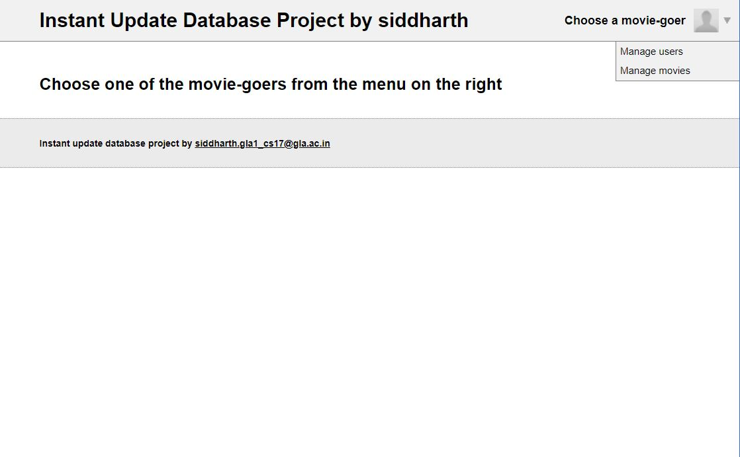
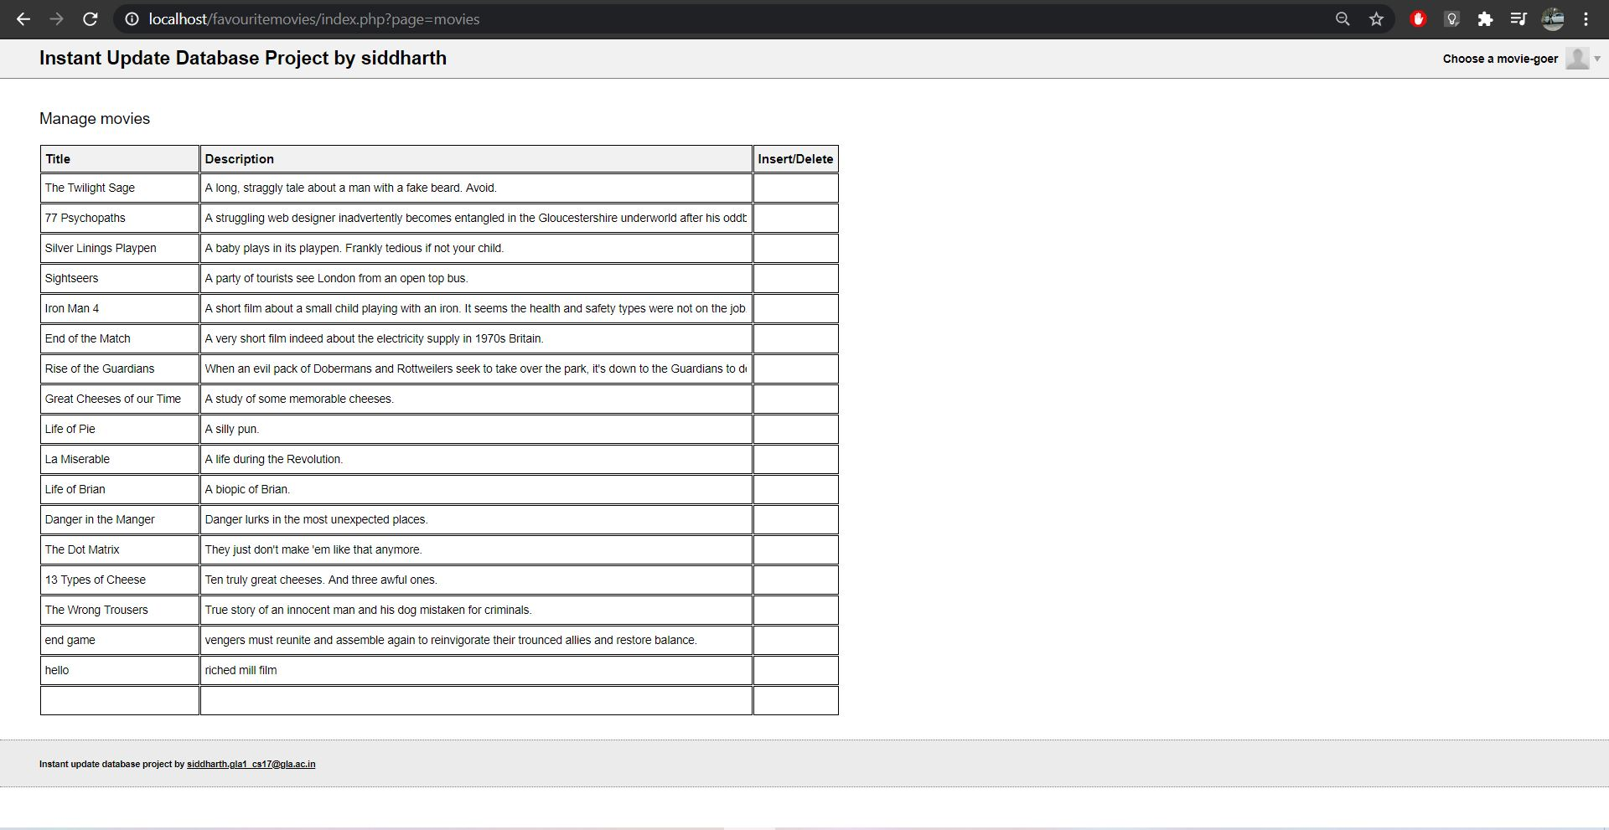
movie list with description

user list 1
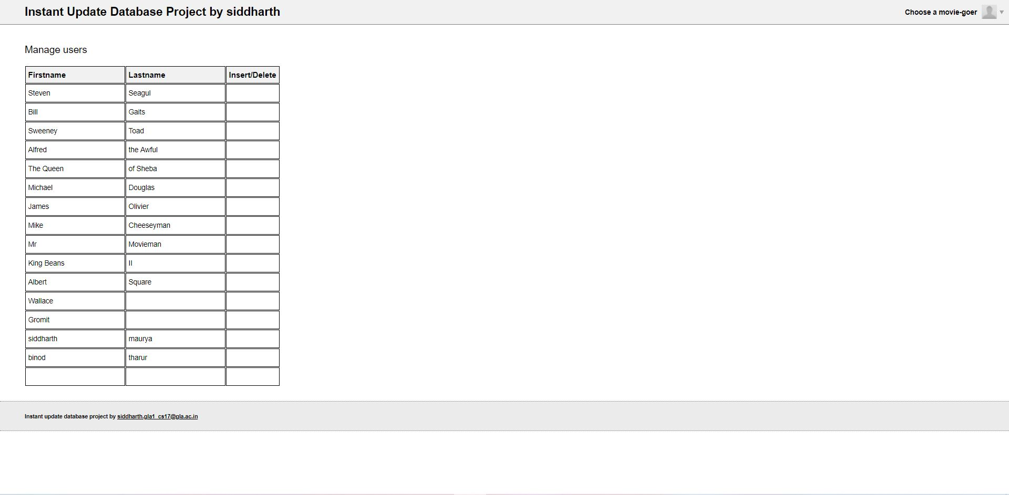

movie lest 1
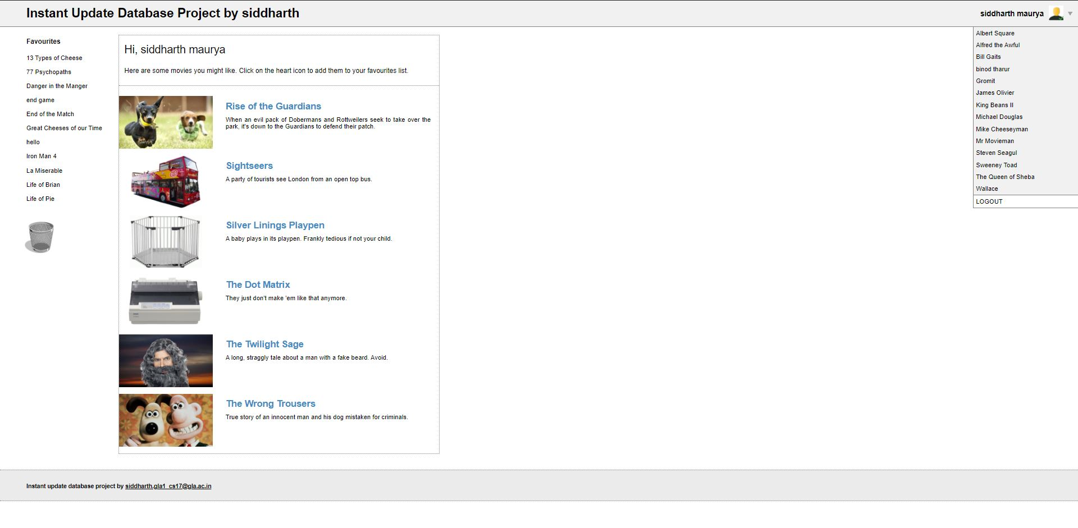
single movie page 1
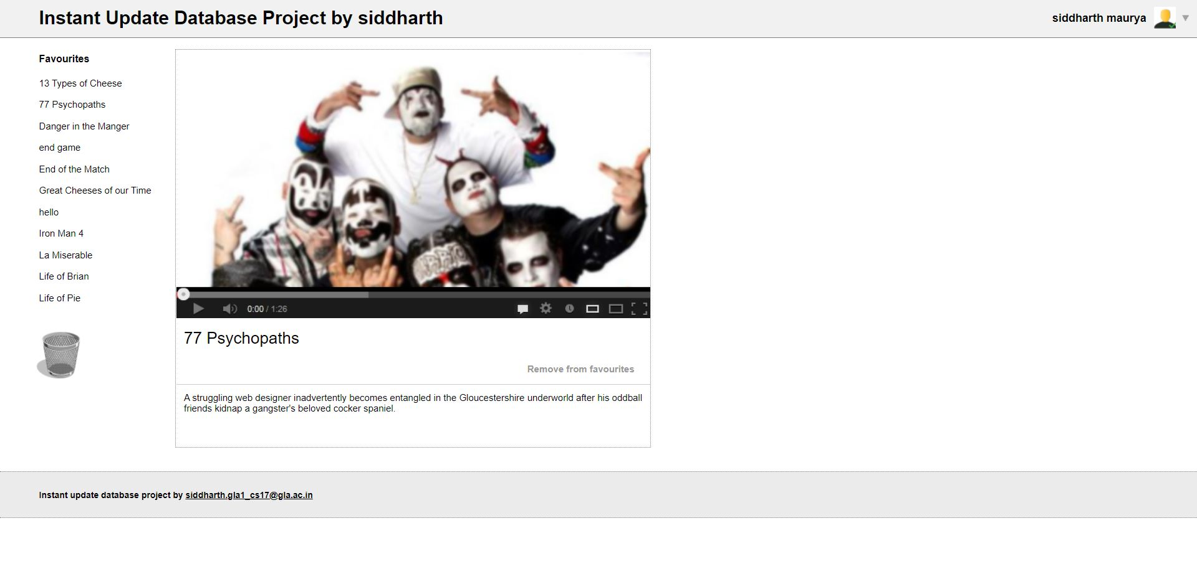

REFERENCE

Web Sites
- www.javatpoint.com
- www.udemy.com
- www.geeksforgeeks.com
- www.w3school.com
- www.tutorialspoint.com
- www.youtube.com
Books
- Learn python the hard way
- Mastering HTML, CSS & JavaScript web publishing
- PHP and MySQL Web development

